The Theory of 2-Dimensional Numbers

Mark McIlroy

© Mark McIlroy 2017. All Rights Reserved
Version 4

Other books by the author

Mark McIlroy is also the author of the following books.
These books are available in print from www.amazon.com and also for free download from the author’s personal website www.markmcilroy.com

Introduction to the Stockmarket
A Pricing Model of Consumption Assets
A guide to writing Excel formulas and VBA macros
The Art and Craft of Computer Programming
SQL Essentials

Background

This theory is independent work by the author, Mark Laurence McIlroy.
I developed this idea around 2011.
For simplicity I’ve used the term 2-Dimensional Numbers throughout, however this idea would more properly be called N-Dimensional Numbers.

CONTENTS

Other books by the author 2
Background 3
1. Description of the model 5
2. 3-dimensional numbers 8
3. Higher orders 9
4. Applications 9
5. Resources 10

Description of the model

A 2-dimensional number is a new type of number, where a single number can represent the location of a point in space.
Normally, it would take several independent co-ordinates to represent the location of a point in space.
Take a square area and divide it into four sub-squares

0 1

2 3

Number the regions 0, 1, 2, 3.
Chose a point at random somewhere inside the main square area.
We will develop a 2-Dimensional number to specify the location of this point.
The sub-square that the point is inside forms the first digit of the 2-dimensional number locating the point.

0 1
.

2 3

In the example above, the point we are considering is located in sub-square number 1.
The first digit of the 2-D number specifying its location would be 1.
Now, continue dividing the reference frame into lower levels of granularity.

0 1
0
.
2 3

2 3

Our point is located in sub-square 3.
This means that the next digit of the 2-D number locating the point will be a 3.
This gives us a total number so far of 13
Dividing into even finer levels may give a 2-D number of 13123, for example.
This 2-D number, 13123, would specify the location of the point in question.
This process can be continued until the required accuracy of specifying the location is achieved.

3-dimensional numbers

The description in section 1 relates to a 2-D number in two dimensions.
A similar process can be applied to higher orders.
For example, a 2-D number in 3 dimensional space would use a reference cube rather than a square, see below.

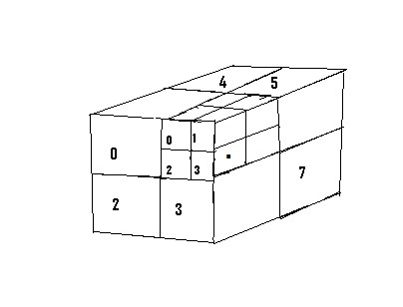
In three dimensional space a reference cube is used instead of a square.
The process of locating a point is exactly the same as the example in section 1, however the cube is divided into eight sub-cubes in turn.
In the example above, the first two digits of the location of the point shown would be 13.

Higher orders

The N-Dimensional number system can be applied to higher order spaces.
While these numbers are difficult to show visually, the same process is used as with the 2-dimensional and 3-dimensional examples.
The space is divided into numbered sub-spaces, until the point in question is specified.

Applications

This number system is extremely general and can be applied to a wide range of practical applications.
Some examples are listed below.

Navigation
Drawing a reference cube around a geographic region would enable any point within that region to be specified.
A location either on land, at sea or in the sky could be specified with a single sequence of digits.
This model could be used for aircraft and ship navigation.
A co-ordinates system using this idea would require 24 digits to specify a location on earth to 1 meter of accuracy.

This is a more complex system than latitude and longitude, however it has the following advantages:
- Only a single sequence of digits is required.
- There are no signs (e.g. East/West) to consider.
- The position reference includes the height above the ground (or below sea level).

Resources

On the author’s personal website www.markmcilroy.com, on the ‘Resources’ tab, the reader can download an Excel spreadsheet where you can experiment with 2-D numbers.

